Project:-1
Object:-
Create a simple webpage using HTML.
Syntax:-
<html>
<head>
<title>My First Webpage</title>
</head>
<body>
<h1>Welcome to My First HTML Page</h1>
<p>This is my first simple HTML webpage.</p>
<p>My name is Rohit Singh. I am learning Web Development.</p>
</body>
</html>

OUTPUT:-

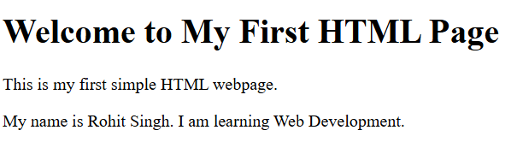

Project:-2
Object:-
Using list tag to crate a list.
#:Order List using “Numbers , Alphabate and Roman Number”.
Syntax:-
<html >
<head>
<title>My Course </title>
<style>

</style>
</head>
<body>
<h1>My Course </h1>
<p>MCA(Master of Computer Application)
<h2>My Subject List</h2>
<ol type="i"> // “type= (1,2,3)/(I,II,III)/(a – z)(A – Z)”
<li>Web Technology (WT)</li>
<li>Database Management System (DBMS)</li>
<li>Java (OOPS)</li>
<li>Operating System(OS)</li>
<li>Data Structure and Algorithm (DSA)</li>
</ol>
</body>
</html>

OUTPUT: 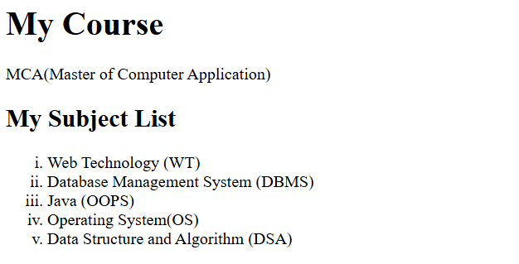

#: Unorderd List using symbols in form of “Square , Circle , Disc”
Syntax:-
<html >
<head>
<title>Subject Teacher </title>
<style>
</style>
</head>
<body>
<h3>Subject Teacher</h3>
<ul type="circle" >
<li>Kiran Pal Sir</li>
<li>Naveen Sir</li>
<li>Raushan Sir</li>
<li>Abhishek Sir</li>
<li>Niteesh Sir</li>
</ul>
</body>
</html>

Output:-
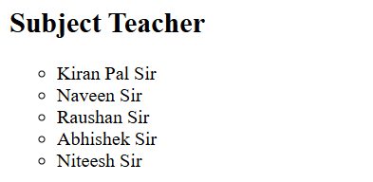

#. Discription List: It is like heading or paragraph form.
Syntax:-
<html>
<head>
<title>Discription List</title>
</head>
<body>
<dl>
<dt> HTML</dt
<dd>Hyper Text Markup Langauge </dd>
<dt>CSS</dt>
<dd>Cascading Style Sheet</dd>
</dl>
</body>
</html>
OUTPUT:-
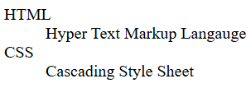

PROJECT:-3
Object:
Using Table Tag Make Student Marks List.
Syntax:
<html>
<head>
<title>Student Data</title>
<style>
.
</style>
</head>
<body>
<table border="3px">
<ol>
<tr><th colspan="7"><h1>Student Marks</h1></th></tr>
<tr>
<th>Student Name</th>
<th>Roll.No</th>
<th>Course</th>
<th>Theory Marks</th>
<th>Practical Marks</th>
<th>Total Marks</th>
</tr>
<tr align="center">
<td>Rohit Singh</td>
<td>2502160140047 </td>
<td>MCA</td>
<td>70</td>
<td>30</td>
<td>100</td>
</tr>
<tr align="center">
<td>Rajeev Kumar</td>
<td>2502160140044 </td>
<td>MCA</td>
<td>70</td>
<td>30</td>
<td>100</td>
<tr align="center">
<td>Arpit Shubham</td>
<td>2502160140018 </td>
<td>MCA</td>
<td>70</td>
<td>30</td>
<td>100</td>
</tr>
<tr align="center">
<td>MD.Aiyaz</td>
<td>2502160140037</td>
<td>MCA</td>
<td>70</td>
<td>30</td>
<td>100</td>
</tr>
</table>
</body>
</html>

Output :
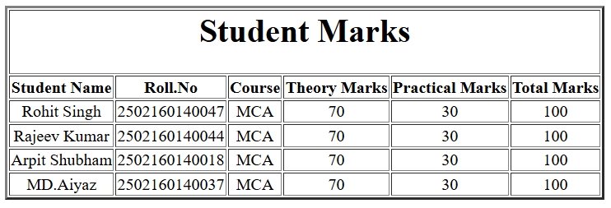

Project:-4
Object:
Using table tag make Time Table.
Syntax:
<html>
<head>
<title>Time Table</title>
<style>
.rotate{
transform: rotate(90deg);
font-family: 'Courier New', Courier, monospace;
font-weight: bold;
}
</style>
</head>
<body>
<table border="4px" cellpadding="4" cellspacing="2px" >
<tr><th colspan="9" ><h1 align="center">MCA Time Table</h1></th></tr>
<tr>
<th>DAY/TIME</th>
<th>First(I)/9.30-10.30</th>
<th> Second(II)/10.30-11.30</th>
<th>Third(III)/11.30-12.30</th>
<th>LUNCH/12.30-1.20</th>
<th>Fourth(IV)/1.20-2.20</th>
<th>Fifth(V)/2.20-3.20</th>
<th>Sixth (VI)3.20-4.20</th>
<th>Seventh(VII)4.20-5.00</th>
</tr>
<tr align="center">
<td>Monday</td>
<td>Web Technology</td>
<td>DBMS</td>
<td>PDP</td>
<td style="border:none" rowspan="5" class="rotate">L U N C H</td>
<td>DSA</td>
<td>LAB</td>
<td>OOPS</td>
<td>Remidial</td>
</tr>
<tr align="center">
<td>Tuesday</td>
<td>VAC</td>
<td>DSA </td>
<td>DBMS</td>
<td>OOPS</td>
<td>LAB</td>
<td>WT</td>
<td>Remidial</td>

</tr>
<tr align="center">
<td>Wednesday</td>
<td>DSA</td>
<td>DBMS</td>
<td>WT</td>
<td>OOPS</td>
<td>LAB</td>
<td>OOPS</td>
<td>Remidial</td>
</tr>
<tr align="center">
<td>Thursday</td>
<td>OOPS</td>
<td>DBMS</td>
<td>PDP</td>
<td>DSA</td>
<td>LAB</td>
<td>OS</td>
<td>Remidial</td>
</tr>
<tr align="center">
<td>Friday</td>
<td>VAC</td>
<td>DBMS</td>
<td>WT</td>
<td>DSA</td>
<td>DBMS</td>
<td>OS</td>
<td>Remidial</td>
</tr>
</table>
</body>
</html>

Output:-
